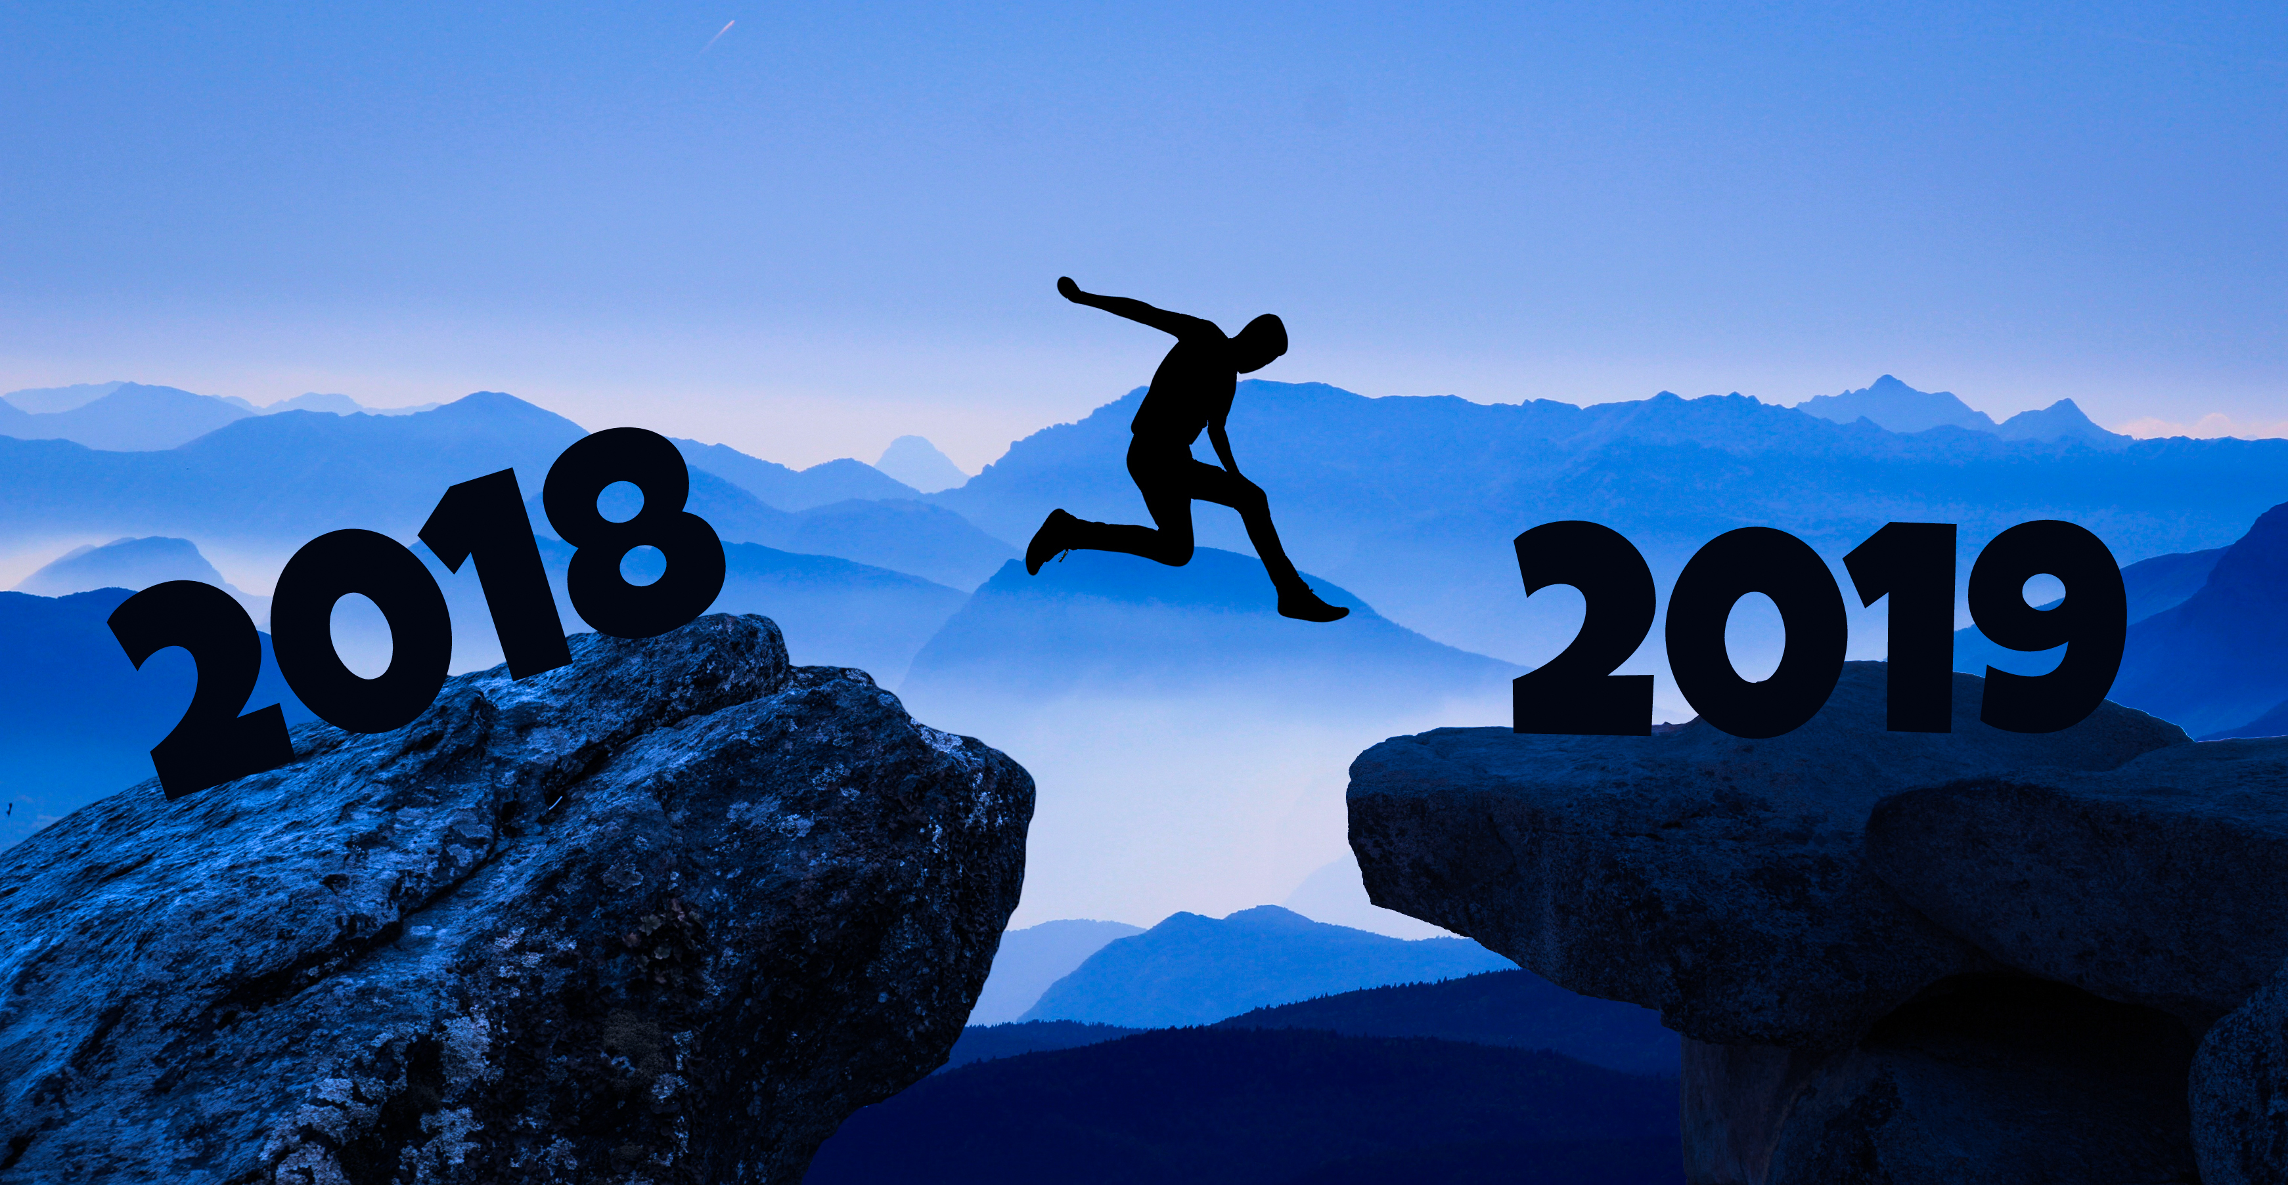
(Belated) Happy Holidays 2018
Let 2019 be better than 2018.
The big news this year is that in November my parents and my stepsister both lost their houses to the Camp Fire in Paradise, California. They’re doing OK, and the insurance paid off. They’ve been staying with relatives for a couple months; my stepsister is moving heaven and earth to get them a permanent housing situation.
I wasn’t even there, but the fire makes me think about how everything is ephemeral. When I use my favorite spoon. When I wear a souvenir sweatshirt. It all could be gone, any time. Still, I’m very glad of the things I took home when they downsized 5 years ago. Small Swedish tablecloths, some crystal, a few other mementos. Those didn’t burn! (Yet.) It is all so very ephemeral.
Meantime, the kids are teenagers! Jocelyn has not yet learned to drive, so we’re still ferrying her to and fro her continuing circus activities. She’s agreed to start the onerous Massachusetts requirements in March, so hopefully before the summer she’ll be able to ferry herself. Perry shows no interest in driving, which is probably for the best.
We have begun the College Search, visiting a couple of schools with Jocelyn and one so far with Perry. We’ve got about 12 months before early applications are due. Jocelyn has visited both ordinary colleges and specialty circus colleges. Which are more like trade schools than college; there is very little academics. She’s completely unsure which direction she’ll go.
I did a lot of traveling to California this past year, and it looks like I’ll be continuing that into next year. The kids went to Puerto Rico in the summer, but without me, as I was on one of my many California trips. The three of us visited my parents for Christmas and had a nice mini family reunion at Clear Lake with my aunt and some cousins.

