Happy Holidays 2017
Our big trip this year was to see the Eclipse in Oregon. Some hassles with trip planning, but in the end it went off just fine. Looking forward to seeing the next one in Mazatlán in 2024!
Jocelyn has intensified her study of circus, taking up other aerial arts in addition to silks, and spending a lot of time at the circus studio. She has been invited to Live Auditions for Circus Smirkus. This is the third year of submitting a video audition, and the first time for Live Auditions. If she gets in, it will take up the entire summer. She has a boyfriend now, plus she’s still working at the rock climbing gym, generally only teaching silks for one hour on Saturday morning. She is still managing to do all her schoolwork well despite these demands on her time. We’re spending a lot of time driving her around. She won’t be able to drive herself for another year.
It would be hard for Perry to “intensify” his study of computers, since he does it so much! Once again he’s entered Google’s programming contest. Last year he worked at it enough to win a tshirt. He has also been studying chess, and going to occasional tournaments. He’s still doing very well in school, though he complains it takes time away from his computer! Of course his favorite class is 3-D Animation. He submitted a recent project to an arts council, which is running an arts award series. I’m guessing he won’t actually win, but it’s still cool to enter.
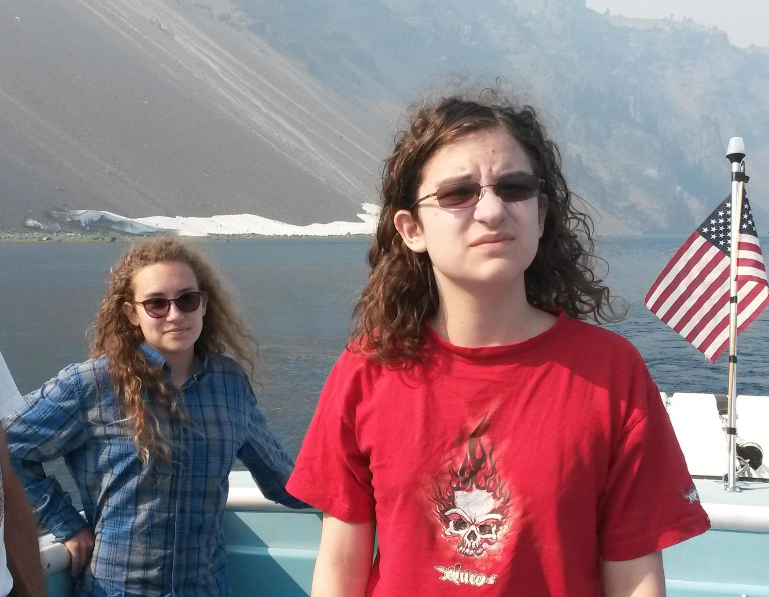
On the boat on Crater Lake the day after the Eclipse

